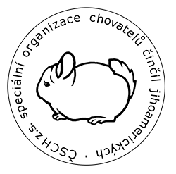
European Championship 2019/2020
Czech Chinchilla Show
Prague 1st February 2020

Application for breeders and visitors. Luch+dinner reservation

Lunch: pea cream soup
1) chicken meat, potatoes
2) curry cauliflower, rice ( vege)
Price 125Kč 5€ - Lunch in dining room

Dinner: bean goulash (legumes). bread
price 100Kč 4€ - Dinner in show area

Breeders+family entrance for free. Visitors 50Kč (2€)

Appications deadline : 21.1. 2020

name | lunch YES - NO | lunch 1-2 | dinner  YES- NO | breeder or visitor? | price in total

